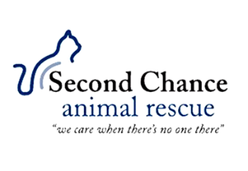
(603) 259-3244
secondchancear.org@gmail.com
SPAY/NEUTER CLINIC INFORMATION
Dear Pet Owner,
We’re pleased that you’re participating in our spay/neuter clinic. Please review the following information carefully.
LOCATION: 1517 Meadow Street Littleton, NH 03561
DIRECTIONS: From I-93, North or South, take Exit 42. Take Rte. 302 West. Go 2.2 miles. We’re the white farmhouse on the left.
DROP OFF TIME: 7:30 AM to 8:30 AM PICK UP TIME: 4:00 PM to 5:00 PM
PRICING: *CASH ONLY at time of drop off. No credit cards, debit cards or checks*
Cats Dogs Rabbits
Spay $50 $150 $100
Neuter $45 $135 $100
All Vaccines $10 each $10 each N/A
Microchipping $20 $20
FeLV/FIV Test $20 N/A N/A
If applicable, please either bring your pet’s current RABIES CERTIFICATE or have your veterinarian email it to us prior to clinic day (a rabies tag is not sufficient proof). By law, cats and dogs must either be current on their rabies vaccination, or must receive one on the day of the spay/neuter clinic. If your pet is due for their rabies booster and you intend to have them receive a three-year rabies certificate, you still must bring or send their previous RABIES CERTIFICATE. If you do not, your pet can only receive a one-year rabies certificate rather than a three-year. Cats must be in carriers and dogs must be on leashes.
PRESURGERY INSTRUCTIONS: If your pet is OVER five months old, do not allow him/her to eat any food after midnight the night before surgery. You can give water. If your per is LESS than five months old, feed him/her at 6:00 AM the day of surgery. You can also give water. Please give your pet a bathroom opportunity before drop off at our facility.
CANCELLATIONS: Please let us know as soon as possible if you cannot keep this appointment. There Is ALWAYS a waiting list for appointments. Another pet is always waiting!

